* Link to your GitHub repository:
  + <https://github.com/Baboolal-B/csd-420>
* Screenshot of your GitHub repository.
  + 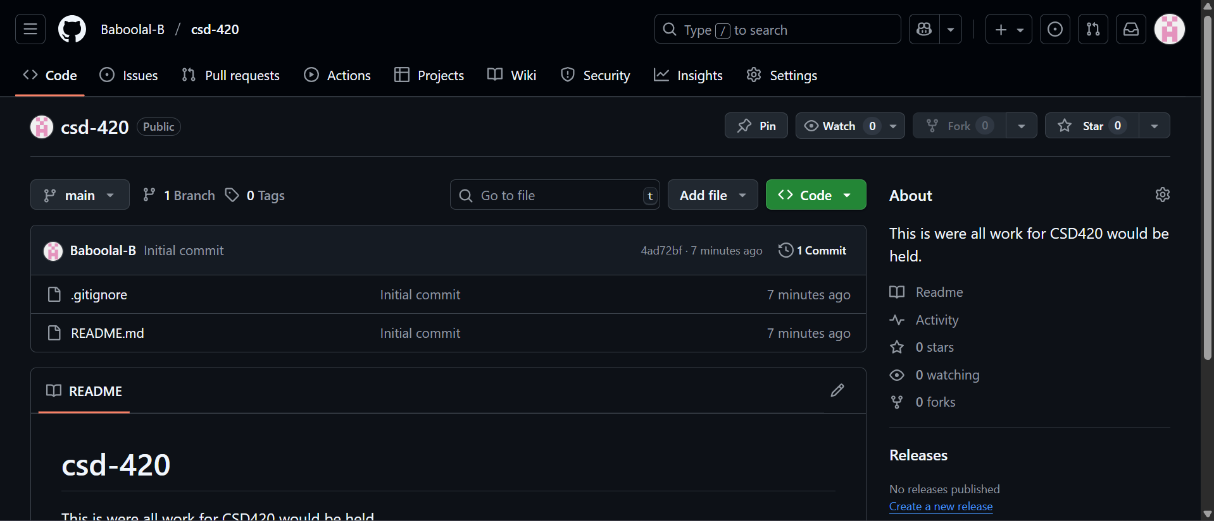
* Screenshot of your local directory (properly formatted).
  + 
   